mkdir flask-webdemo

cd flask-webdemo

mkdir templates  
  
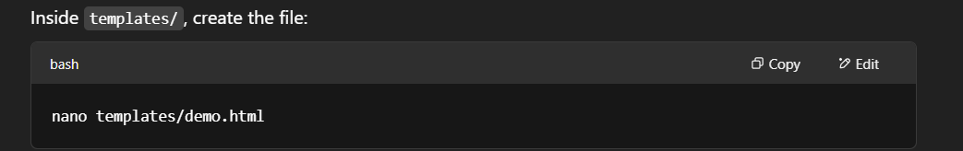

<!DOCTYPE html>

<html>

<head>

<title>Login Page</title>

</head>

<body>

<h2>{{ msg }}</h2>

<form method="POST" action="/">

<input name="username" placeholder="Username" required>

<input type="password" name="password" placeholder="Password" required>

<button type="submit">Login</button>

</form>

</body>

</html>

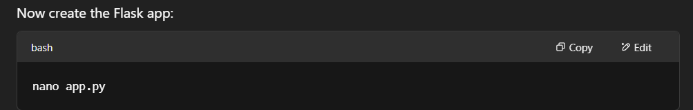

from flask import Flask, session, request, redirect, render_template

from datetime import datetime

app = Flask(__name__)

app.secret_key = 'supersecretkey'

@app.before_request

def log_request():

with open("access.log", "a") as f:

f.write(f"[{datetime.now()}] IP: {request.remote_addr} | Agent: {request.user_agent} | Path: {request.path} | Method: {request.method} | Session: {session.get('user', 'None')}\n")

@app.route("/", methods=["GET", "POST"])

def login():

if request.method == "POST":

username = request.form.get("username")

password = request.form.get("password")

session['user'] = username

return f"<h2>Welcome {username}</h2><p><a href='/logout'>Logout</a></p>"

return render_template("demo.html", msg="Login Page")

@app.route("/logout")

def logout():

session.pop('user', None)

return redirect("/")

if __name__ == "__main__":

app.run(debug=True)

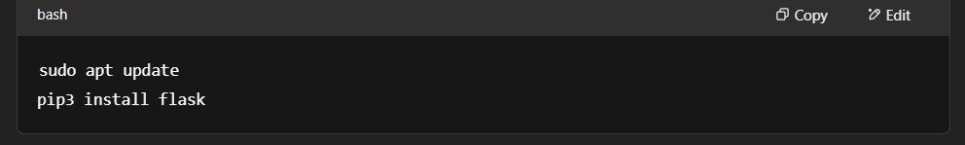

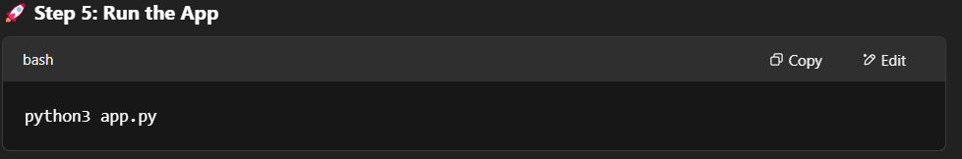

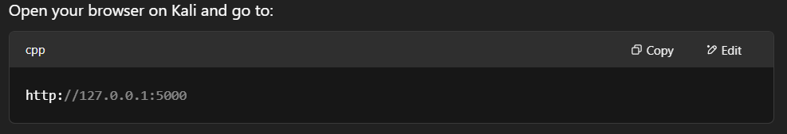

from flask import Flask, session, request, redirect, render_template_string

from datetime import datetime

app = Flask(__name__)

app.secret_key = 'supersecretkey'

# HTML template

html = '''

<h2>{{ msg }}</h2>

<form method="POST">

<input name="username" placeholder="Username" required>

<input type="password" name="password" placeholder="Password" required>

<button type="submit">Login</button>

</form>

'''

# Log every request to access.log

@app.before_request

def log_request():

with open("access.log", "a") as f:

f.write(f"[{datetime.now()}] IP: {request.remote_addr} | Agent: {request.user_agent} | Path: {request.path} | Session: {session.get('user', 'None')}\n")

@app.route("/", methods=["GET", "POST"])

def login():

if request.method == "POST":

username = request.form.get("username")

password = request.form.get("password")

# ✅ This prints user credentials to terminal (demo only!)

print(f"User tried to login with -> Username: {username}, Password: {password}")

session['user'] = username

return f"<h2>Welcome {username}</h2><p><a href='/logout'>Logout</a></p>"

return render_template_string(html, msg="Login Page")

@app.route("/logout")

def logout():

session.pop('user', None)

return redirect("/")

if __name__ == "__main__":

app.run(debug=True)